St Margaret’s-Bethel-St Mark’s
Winter Study
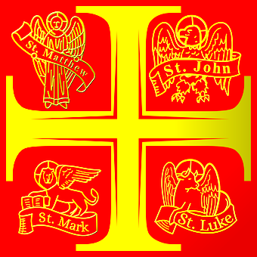
Matthew, Mark, Luke and John
Most of what we can reliably know about Jesus’ time on earth comes from these four guys. Who were they? How did they collect the information about Jesus? Why are some bits repeated while other bits appear to be contradictory?
They are called evangelists and the books they wrote gospels: good news. Can they be relied upon? Is it still good news for people in the 2020’s?
Starting on Wednesday 22nd January, we will be exploring the four gospels over four weeks beginning with Matthew. Come and join us. Each evening will begin at 7.30pm with a short time of worship and prayer. The study will be neither too heavy or too light and we shall be done by 9.00pm. Lifts on request.
Meeting at 3 Criagmillar Road LL12 7AR
Contacts: Jonathan Mob: 07835 353068 email: jonathan@plwyfwrecsam.org.uk
Rebecca Tel: 01978 291621 email: curateofwrexham@outlook.com
St Margaret’s-Bethel-St Mark’s
Winter Study
Matthew, Mark, Luke and John
Most of what we can reliably know about Jesus’ time on earth comes from these four guys. Who were they? How did they collect the information about Jesus? Why are some bits repeated while other bits appear to be contradictory?
They are called evangelists and the books they wrote gospels: good news. Can they be relied upon? Is it still good news for people in the 2020’s?
Starting on Wednesday 22nd January, we will be exploring the four gospels over four weeks beginning with Matthew. Come and join us. Each evening will begin at 7.30pm with a short time of worship and prayer. The study will be neither too heavy or too light and we shall be done by 9.00pm. Lifts on request.
Meeting at 3 Criagmillar Road LL12 7AR
Contacts: Jonathan Mob: 07835 353068 email: jonathan@plwyfwrecsam.org.uk
Rebecca Tel: 01978 291621 email: curateofwrexham@outlook.com

